**Requirement Gathering and Analysis Phase**

**Technology Stack (Architecture & Stack)**

|  |  |
| --- | --- |
| Date | 04-07-2024 |
| Team ID | SWTID1719929609 |
| Project Name | Project – BookNest |
| Maximum Marks |  |

**Technical Architecture:**

The architecture for the bookstore website includes several components, each responsible for different aspects of the application. The chosen stack ensures scalability, security, and performance

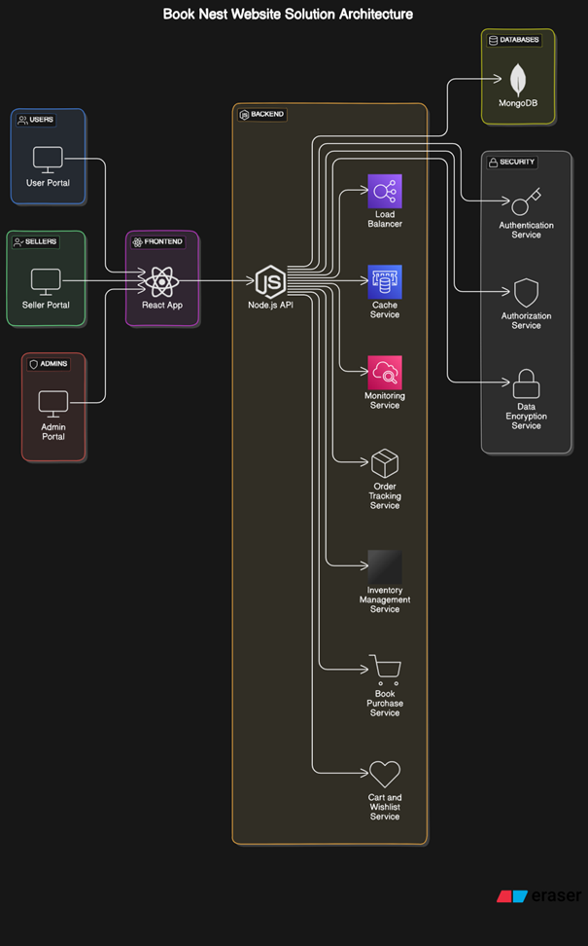

**Table-1 : Components & Technologies:**

|  |  |  |  |
| --- | --- | --- | --- |
| **S.No** | **Component** | **Description** | **Technology** |
|  | Web UI | How users interact with the application. | HTML, CSS, JavaScript, React.js |
|  | Backend for business logic | Handles user requests, authentication, and business logic. | Node.js, Express.js |
|  | Database | Stores book data, user profiles, and order details. | Mongodb |
|  | Cloud Database | Database Service on Cloud | MongoDB Atlas |
|  | File Storage | Storage requirements for user data and media. | Local Filesystem |

**Table-2: Application Characteristics:**

| **S.No** | **Characteristics** | **Description** | **Technology** |
| --- | --- | --- | --- |
|  | Open-Source Frameworks | List the open-source frameworks used | React.js, Node.js, Express.js, MongoDB |
|  | Security Implementations | List all the security / access controls implemented, use of firewalls etc. | HTTPS,Network ACLs |
|  | Scalable Architecture | Justify the scalability of architecture (3 – tier, Micro-services) | Microservices |
|  | Performance | Design consideration for the performance of the application (number of requests per sec, use of Cache, use of CDN’s) etc. | MongoDB indexing |